Joint Optimal Service Chain Allocation, VNF instantiation and Metro Network Resource Management Demonstration

Author name(s) [10-point type, centered, bolded]
¹Universidad Politécnica de Cartagena, Cuartel de Antiguones, Plaza del Hospital 1, 30202 Cartagena, Spain
Email: javier.moreno@upct.es

Abstract: In a metro network with VIMs orchestrated by an ETSI-OSM instance, and an optical transport controller, we demonstrate optimized service chain provisioning using the open-source Net2Plan tool with interfaces to OSM (new) and transport controller.
OCIS codes: (060.4250) Networks; (060.4256) Network Optimization.

1. Introduction
Metropolitan area networks play an essential role in telecom operators’ infrastructure to satisfy the near-future requirements of the 5G era. Among other key performance indicators, 5G networks are expected (i) to use a scalable management framework enabling fast deployment of novel applications, (ii) to reduce the network management OPEX by at least 20% compared to today and (iii) to ensure End-to-End latency below 1 ms. Software-defined networking (SDN) network function virtualization (NFV) are key technologies to address (i) because they enable dynamic management of virtual network functions (VNFs) across an advanced programmable network. Moreover, (ii) can be met instantiating VNFs in standard commodity hardware and exploiting hardware disaggregation and multi-vendor interoperability with SDN. Finally, optimization is imperative to guarantee (iii) by fully exploiting the network resources and allocating service chains (SCs) of multiple VNFs in the most efficient manner.
In this context, the Metro-Haul project [1] proposes cost-effective, energy-efficient, agile and programmable metro networks that are scalable for 5G access and future requirements, designing metro nodes, which interface effectively with both 5G access and multi-Tbit/s elastic core networks. In a Metro-Haul network, Access Metro Edge Nodes (AMENs) and Metro Core Edge Nodes (MCENs) are interconnected through dynamic optical bandwidth allocation and equipped with full compute and storage resources and networking (transmission and switching) capabilities. MCENs are dimensioned with more IT resources than AMENs due to its proximity to the core network and core data centers (DC).
2. Overview
This demonstration proofs the use of the specialized open-source planning tool Net2Plan [2] to assist the NFV-Orchestrator (NFV-O) Open-Source MANO (OSM) [3] in the optimal VNF instantiation, SC allocation and optimization of transport network. An overview of the demonstration is shown in Fig. 1, which is composed of the following control (IT and network) modules:
- Operations Support System (OSS) represents an operator that deploys an application service. A user can request SC-based demands through a GUI programmed in Net2Plan to emulate operator’s behavior.
- NFV-O OSM orchestrates the IT infrastructure leveraging hierarchically in VIMs to properly deploy and manage VNFs in diverse node sites.
- Netphony is a BGP-LS Speaker, Traffic Engineering Database and Topology Module which emulates the transport network. It contains the T-SDN controller which exposes interfaces to receive commands from the OSS and to provide multi-layer information to the SCCE.
- Service Chain Computation Element (SCCE) is an evolution of the well-known Path Computation Element (PCE) which computes path routing in addition to address service chain allocation requests. Tasks of the SCCE are managed by the planning tool Net2Plan.
The proof of concept also demonstrates the use of the following open interfaces:
- Management Interfaces: (i) OSS-SCCE, a SSCE Protocol, enables a bidirectional communication between the OSS and SCCE modules. We will investigate two options for implementing this interface, an extension of PCEP protocol (e.g. adapting some of the concepts in RFC 2119 [ref?], adapted to SDN/NFV context) or a Rest-API based on YANG model definitions. (ii) OSS-T-SDN, a usual SDN North Bound Interface is used by the operator to notify Netphony about the changes to apply in the emulated transport network. This interface is compliant with the well-known ONF Transport (T)-API [ref?]. (iii) OSS-NVF-O, the OSM Rest-API allows the OSS to lead NFV-O in order to apply changes in the IT resources and the NFV infrastructure.
- Monitoring Interfaces: (i) NFV-O-SCCE, SCCE is always aware of NFVI and IT resources via Rest-API provided by OSM and (ii) T-SDN-SCCE, Netphony delivers asynchronously the network state to SCCE through the BGP-LS protocol.
The demonstration follows the following workflow. (i) A user introduces the SC-based request through the Net2Plan GUI, providing: the origin and end nodes within the emulated network, the sorted sequence of VFs to traverse and the demand size in Gbps. (ii) The request arrives to the SCCE that has the complete knowledge of the VNFs, IT and network resources, it executes an algorithm to obtain the - optimum SC allocation and it sends the results to the OSS. (iii) The operator informs NFV-O where and how to use the available IT resources and the VNFs to traverse, and also is in charge to send Netphony the orders to apply in the emulated transport network.

A la derecha de la figura 1 hacemos un “time domain diagram” del workflow tipo: 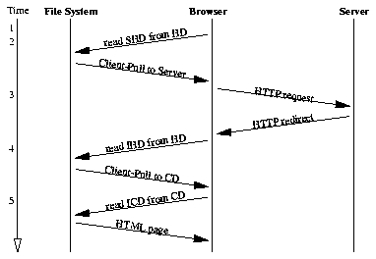???

Del comentario:
“Hay dos formas:
- Net2Plan recibe orden de usuario y realiza proactivamente interacciones con OSM y NetPhony
- Usuario da orden a OSM, hackeamos OSM para que pregunte a Net2Plan sobre allocation. Net2Plan entonces hace lo mismo que antes (aunque con OSM como respuesta).”
Entiendo que toda la demo se basa en la primera opción y no se comenta la segunda.
Por lo tanto, tampoco hace falta hablar de:
“- De manera periódica Net2plan recibe via OSM el uso de los recursos de computación y de T-SDN (netphony), el estado de la red”

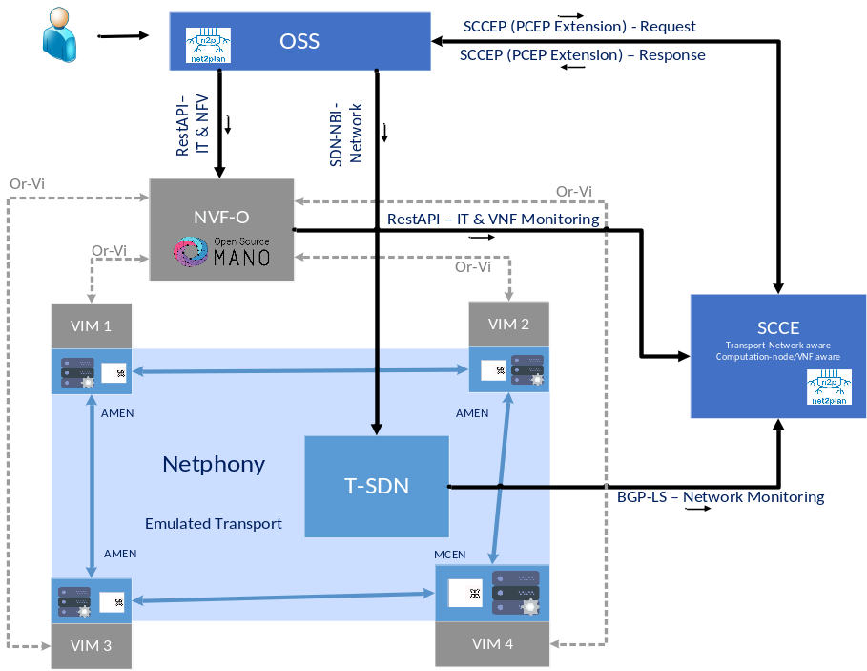
Fig. 1. Demonstration overview. NFV-O: Network Function Virtualization - Orchestrator. OSS: operational support systems VIM: Virtual infrastructure manager. Netphony: BGP-LS Speaker and Traffic Engineering Database
3. Innovation
SDN and NFV are, not only two of the most promising work fields in the current state of optical management research, but also a reality. Most of the state-of-the-art demonstrations are oriented to provide SDN- or NVF-based use cases, however optimality in service chain allocation is not usually taken into account [4][5]. In this work, we present a novel SDN-NFV framework which interacts with the planning tool, Net2Plan, to assess an effective way to allocate SC-based demands ease the satisfaction of 5G KPIs.
4. OFC Relevance
The proposed demonstration is relevant to OFC since it offers a proof-of-concept in a dynamic SDN/NFV environment optimized by a planning tool in order to test some operator’s tasks within the incoming 5G era totally relevant for the extremely challenging forecasted Internet scenario.
Acknowledgments
The research leading to these results has received funding from the European Commission for the H2020-ICT-2016-2 METRO-HAUL project (G.A. 761727). INSPIRING-SNI???.
References
- Metro-Haul Project. https://metro-haul.eu/
- P. Pavon-Marino et al., “Net2Plan: An Open Source Network Planning Tool for Bridging the Gap between Academia and Industry”, IEEE Networks, Sept. 2015.
- Open Source Mano. [Online]. Avalilable: https://osm.etsi.org/
- V.Mehmeri et. al., “Software-Programmed Optical Networking with Integrated NFV Service Provisioning”, OFC 2017, March 2017
- A. Hammad et. al., “Demonstration of NVF Content Delivery using SDN-enabled virtual infrastructures”, OFC 2017, March 2017

